Pabna University of Science and Technology

Faculty of Engineering and Technology
Department of Information and Communication Engineering
Lab Report
Course Code: ICE-2204
Course title: Signals and Systems Sessional
Submitted By:  Name: Mst. Khaleda Khatun  Roll: 220640  Session:2021-2022  2nd Year 2ndsemester  Department of Information and  Communication Engineering,  PUST. | Submitted To:  Name: Dr. Md. Imran Hossain  Associate Professor  Department of Information and Communication Engineering,  Pabna University of Science and Technology, Pabna, Bangladesh.
Date of Submission: 04/03/2025
SI No. | Name of Experiment

1. | Signal Operations (Addition, Subtraction, Multiplication, Division, Shifting and Folding.
2. | Signal Sequences(Impulse Signal, Step Signal ,Ramp Signal).
3. | Convolution using Python
4. | Correlation(Cross and Auto) Using Python.
5. | PPG signal lab (a sine signal,noise signal ,signal with add noise ,filtered signal, filtering, feature extraction, peak detection).
6. | Fourier Transform
7. | Fourier Series Decomposition with Harmonics
8 | A lab report on DFT

No of Experiment: 01
Name of Experiment: Signal Operations (Addition, Subtraction, Multiplication, Division, Shifting and Folding.
Objectives: To implement basic signal operations using Python and visualize the results using Matplotlib.
Theory: Signal processing involves various fundamental operations such as addition, subtraction, multiplication, division, shifting, and folding. These operations help us to analyze and modify signals for different applications in communication, control systems, and signal analysis.
- Addition & Subtraction: Performed element-wise on two signals.
- Multiplication & Division: Applied to scale or modulate the signal.
- Shifting: Delays or advances a signal in time.
- Folding (Reversal): Flips the signal about the vertical axis.
Python Code:
import numpy as np
import matplotlib.pyplot as plt

def generate_signal(n, values):
return np.array(values), np.array(n)

def plot_signal(n, x, title):
plt.stem(n, x)
plt.xlabel('n')
plt.ylabel('Amplitude')
plt.title(title)
plt.grid()
plt.show()

# Define discrete signal x[n]
n = np.arange(-5, 6) # Time indices
x = np.array([1, 2, 3, 4, 5, 6, 5, 4, 3, 2, 1])
y = np.array([2, 1, 0, -1, -2, -3, -2, -1, 0, 1, 2]) # Another signal

# Addition
x_add = x + y
plot_signal(n, x_add, 'Signal Addition')

# Subtraction
x_sub = x - y
plot_signal(n, x_sub, 'Signal Subtraction')
# Multiplication
x_mul = x * y
plot_signal(n, x_mul, 'Signal Multiplication')

# Division (Handling zero division case)
x_div = np.where(y != 0, x / y, 0)
plot_signal(n, x_div, 'Signal Division')

# Right Shift (Delay by 2)
n_shift_right = n + 2
plot_signal(n_shift_right, x, 'Right Shifted Signal')

# Left Shift (Advance by 2)
n_shift_left = n - 2
plot_signal(n_shift_left, x, 'Left Shifted Signal')

# Folding (Reversal)
n_folded = -n
plot_signal(n_folded, x, 'Folded Signal')
Output:
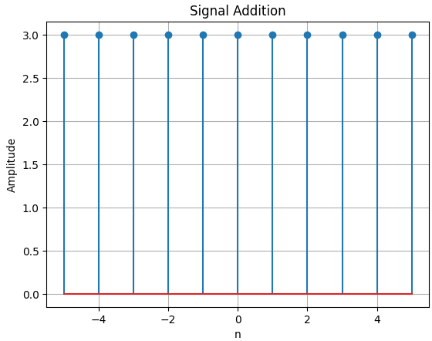 | 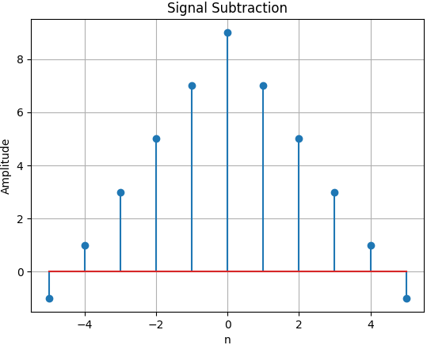 | 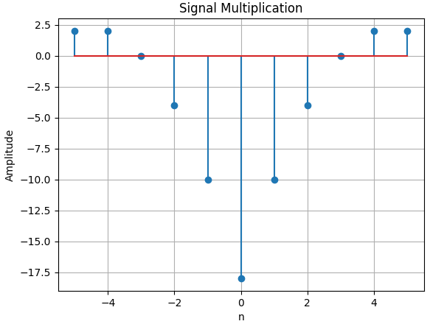
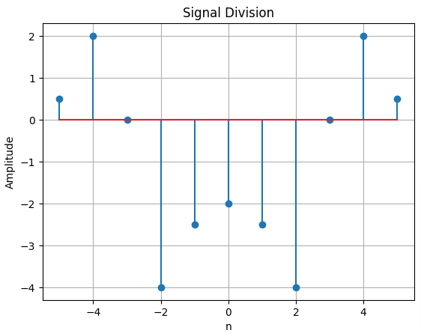 | 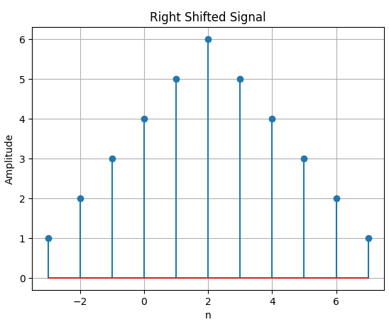 | 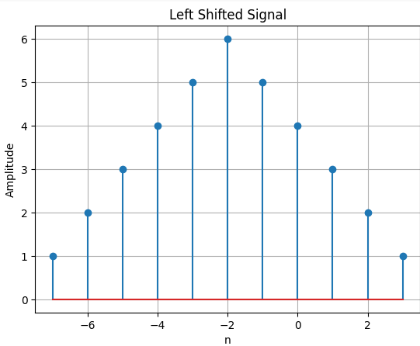
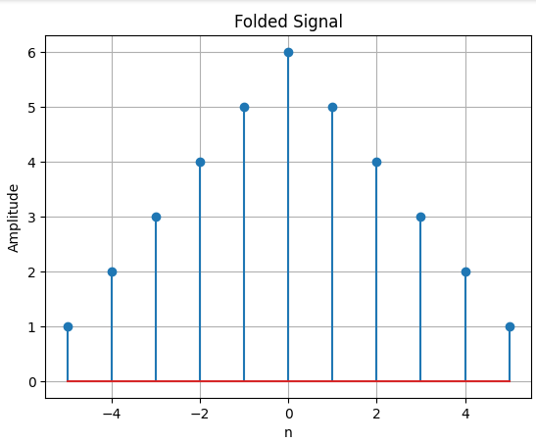

No of Experiment: 02
Name of Experiment: Signal Sequences(Impulse Signal, Step Signal ,Ramp Signal).
Objectives: To generate and visualize basic signal sequences, including impulse, step, and ramp functions, using Python.
Theory: Signal sequences such as impulse, step, and ramp functions are fundamental in signal processing and system analysis. These sequences serve as building blocks for more complex signals and help analyze system responses.
- Impulse Signal (δ[n]): A discrete-time signal that is 1 at n=0 and 0 elsewhere.
- Step Signal (u[n]): A signal that is 0 for n < 0 and 1 for n ≥ 0.
- Ramp Signal (r[n]): A signal that increases linearly with time (n) for n ≥ 0.

Python Code:
import numpy as np
import matplotlib.pyplot as plt
def impulse_signal(n):
return np.where(n == 0, 1, 0)
def step_signal(n):
return np.where(n >= 0, 1, 0)
def ramp_signal(n):
return np.where(n >= 0, n, 0)
def plot_signal(n, x, title):
plt.stem(n, x)
plt.xlabel('n')
plt.ylabel('Amplitude')
plt.title(title)
plt.grid()
plt.show()
# Define discrete time indices
n = np.arange(-10, 11)
# Generate signals
impulse = impulse_signal(n)
step = step_signal(n)
ramp = ramp_signal(n)
# Plot signals
plot_signal(n, impulse, 'Impulse Signal')
plot_signal(n, step, 'Step Signal')
plot_signal(n, ramp, 'Ramp Signal')
Output:
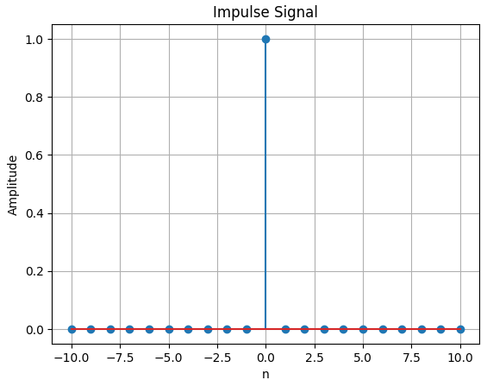 | 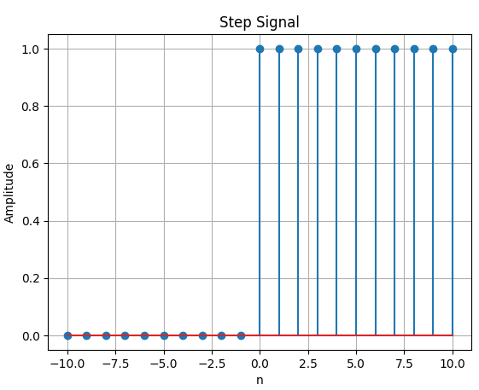
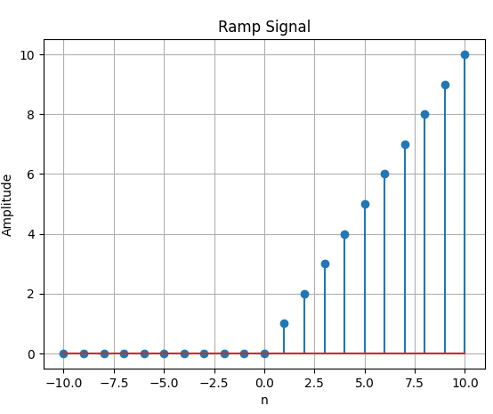

No of Experiment: 03
Name of Experiment: Convolution using Python
Objectives: To implement and visualize the convolution operation on discrete-time signals using Python.

Theory: Convolution is a fundamental mathematical operation that used in signal processing to determine the output of a system when an input signal is given. It is now used in filtering, system analysis, image processing and so on.
- Convolution (x[n] * h[n]): The convolution of two discrete-time signals, and , is defined as:
y[n] = \sum_{k=-\infty}^{\infty} x[k] h[n-k] ]
This operation determines how an input signal is modified by a system's impulse response .

Python Code:
import numpy as np
import matplotlib.pyplot as plt

def plot_signal(n, x, title):
plt.stem(n, x)
plt.xlabel('n')
plt.ylabel('Amplitude')
plt.title(title)
plt.grid()
plt.show()

# Define discrete signals
x = np.array([1, 2, 3, 4]) # Input signal
h = np.array([1, -1, 2]) # Impulse response

# Perform convolution
y = np.convolve(x, h)
n = np.arange(len(y))

# Plot signals
plot_signal(np.arange(len(x)), x, 'Input Signal x[n]')
plot_signal(np.arange(len(h)), h, 'Impulse Response h[n]')
plot_signal(n, y, 'Convolved Signal y[n]')

Output:
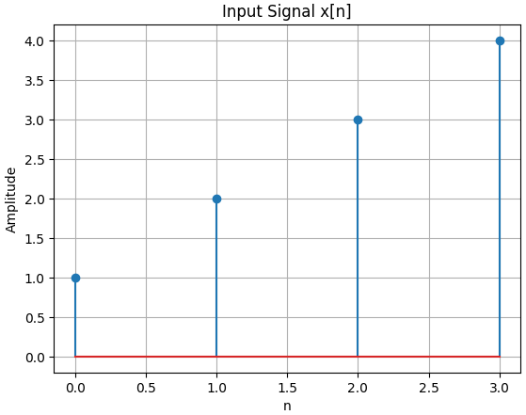
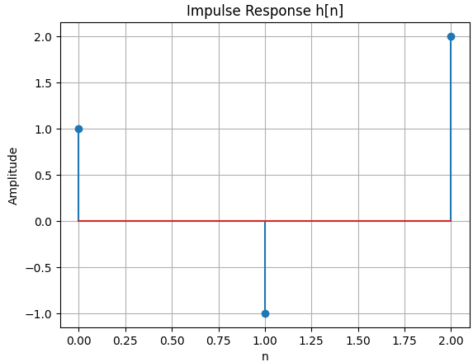
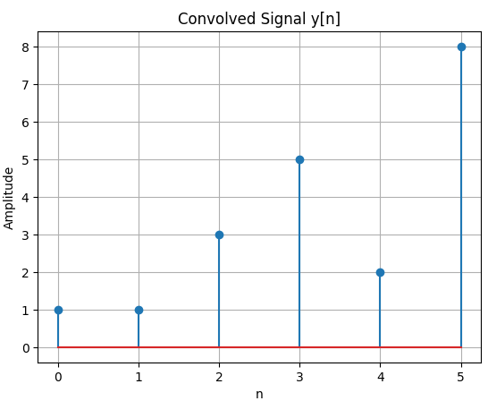
No of Experiment : 04
Name of Experiment : Correlation(Cross and Auto) Using Python.
Objective : To understand and implement correlation techniques, including cross-correlation and auto-correlation, using Python. These techniques are widely used in signal processing, pattern recognition, and data analysis to measure the similarity between signals or time series.

Theory: Correlation is a fundamental operation in signal processing that measures the similarity between two signals. It helps determine how one signal is related to another in terms of time shift and alignment. There are two primary types of correlation:
- Auto-correlation: Measures the similarity of a signal with a delayed version of itself. It is useful in detecting repeating patterns within a signal.
- Cross-correlation: Measures the similarity between two different signals as a function of the time-lag applied to one of them. It is used in signal processing to identify the delay between two signals.
Mathematically, the auto-correlation function (ACF) and cross-correlation function (CCF) are defined as:
Rxx($τ$)= ∑x[n]x[n- $τ$] (Auto correlation) Rxy($τ$)=x[n]y[n-$τ$] (Cross correlation)
Where ($τ$) is the time shift or lag.

Python Code:
import numpy as np
import matplotlib.pyplot as plt

# Define two signals
x = np.array([1, 2, 3, 4, 5])
y = np.array([5, 4, 3, 2, 1])
# Compute auto-correlation
auto_corr_x = np.correlate(x, x, mode='full')
auto_corr_y = np.correlate(y, y, mode='full')
# Compute cross-correlation
cross_corr = np.correlate(x, y, mode='full')
# Define lag values
lags = np.arange(-len(x) + 1, len(x))
# Plot auto-correlation
plt.figure(figsize=(12, 5))
plt.subplot(1, 2, 1)
plt.stem(lags, auto_corr_x)
plt.title("Auto-correlation of x")
plt.xlabel("Lag")
plt.ylabel("Correlation")

# Plot cross-correlation
plt.subplot(1, 2, 2)
plt.stem(lags, cross_corr)
plt.title("Cross-correlation of x and y")
plt.xlabel("Lag")
plt.ylabel("Correlation")

plt.tight_layout()
plt.show()

Output:
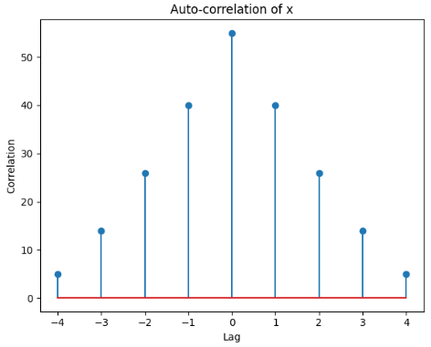
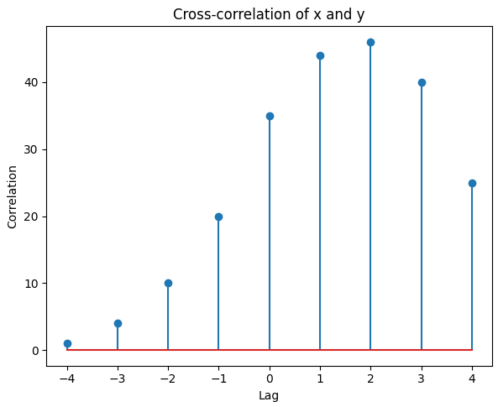
No of Experiment: 05
Name of Experiment: PPG signal lab (a sine signal,noise signal ,signal with add noise ,filtered signal, filtering, feature extraction, peak detection).
Objectives: To generate and process a Photoplethysmogram (PPG) signal using Python. The lab covers the generation of a synthetic sine wave signal, the addition of noise, filtering techniques to remove noise, feature extraction, and peak detection. These steps are essential for analyzing physiological signals in biomedical signal processing.

Theory: A Photoplethysmogram (PPG) signal is a biomedical signal that measures blood volume changes in tissues. It is widely used in heart rate monitoring and other cardiovascular assessments. The signal typically contains periodic components (heartbeats) along with noise from various sources.
- Sine Wave Signal: A synthetic PPG-like waveform is generated using a sine function.
- Noise Addition: Random noise is added to simulate real-world signal artifacts.
- Filtering: A low-pass filter (e.g., Butterworth) is used to remove high-frequency noise.
- Feature Extraction: Extracting meaningful properties such as peaks and pulse intervals.
- Peak Detection: Identifying peaks in the signal corresponding to heartbeats.

Python Code:
import numpy as np
import scipy.signal as signal
import matplotlib.pyplot as plt
def bandpass_filter(data, fs=100):
b, a = signal.butter(4, [0.5 / (0.5 * fs), 5.0 / (0.5 * fs)], btype='band')
return signal.filtfilt(b, a, data)
def detect_peaks(signal_data):
return signal.find_peaks(signal_data, distance=50)[0]
def extract_heart_rate(peaks, fs=100):
if len(peaks) < 2:
return 0 # Properly indented return statement
rr_intervals = np.diff(peaks) / fs
return 60 / np.mean(rr_intervals)
# Generate synthetic PPG signal
fs = 100
t = np.linspace(0, 10, fs * 10)
sine_signal = np.sin(2 * np.pi * 1.2 * t)
noise_signal = 0.1 * np.random.normal(0, 1, len(t))
ppg_signal = sine_signal + noise_signal
# Process PPG signal
filtered_signal = bandpass_filter(ppg_signal, fs)
normalized_signal = (filtered_signal - np.min(filtered_signal)) / (np.max(filtered_signal) - np.min(filtered_signal))
peaks = detect_peaks(normalized_signal)
heart_rate = extract_heart_rate(peaks, fs)
# Print results
print("Filtered Signal (first 10 values):", filtered_signal[:10])
print("Detected Peaks (first 10 indices):", peaks[:10])
print(f"Estimated Heart Rate: {heart_rate:.2f} BPM")
# Plot results
plt.figure(figsize=(12, 9))
plt.subplot(3, 2, 1)
plt.plot(t, sine_signal, label='Raw Sine Signal')
plt.xlabel("Time")
plt.ylabel("Amplitude")
plt.legend()
plt.subplot(3, 2, 2)
plt.plot(t, noise_signal, label='Raw Noise Signal')
plt.xlabel("Time")
plt.ylabel("Amplitude")
plt.legend()
plt.subplot(3, 2, 3)
plt.plot(t, ppg_signal, label='Raw PPG Signal')
plt.xlabel("Time")
plt.ylabel("Amplitude")
plt.legend()
plt.subplot(3, 2, 4)
plt.plot(t, filtered_signal, label='Filtered PPG Signal')
plt.xlabel("Time")
plt.ylabel("Amplitude")
plt.legend()

plt.subplot(3, 2, 5)
plt.plot(t, normalized_signal, label='Normalized PPG Signal')
plt.xlabel("Time")
plt.ylabel("Amplitude")
plt.legend()

plt.subplot(3, 2, 6)
plt.plot(t, normalized_signal, label='PPG with Detected Peaks')
plt.plot(t[peaks], normalized_signal[peaks], 'ro', label='Detected Peaks')
plt.xlabel("Time")
plt.ylabel("Amplitude")
plt.legend()

plt.tight_layout()
plt.show()

Output:
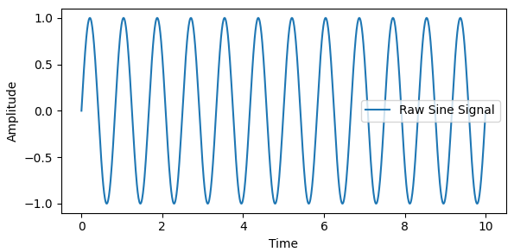 | 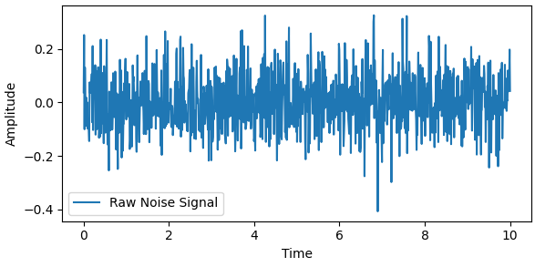
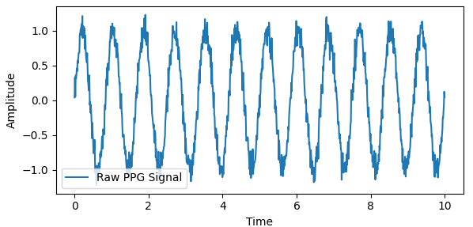 | 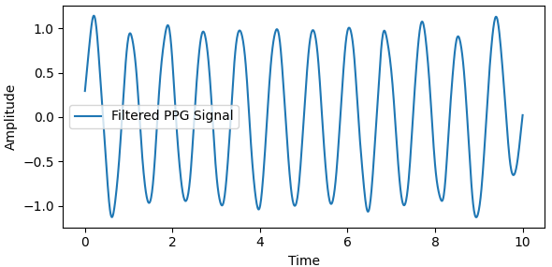
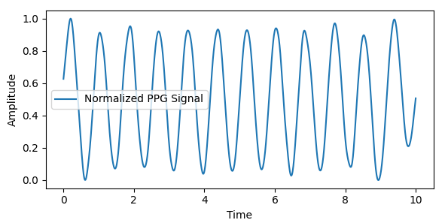 | 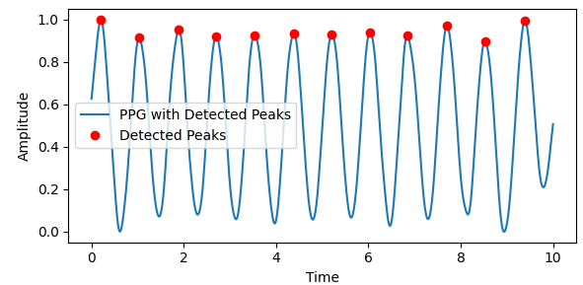

No of Experiment: 06
Name of Experiment: Fourier Transform
Objectives: To understand and implement the Fourier Transform in signal and system analysis using Python. The Fourier Transform is essential for converting time-domain signals into their frequency-domain representation, which helps in analyzing the frequency components of signals.

Theory: The Fourier Transform is a mathematical technique that transforms a time-domain signal into its frequency-domain representation. It is widely used in signal processing to analyze periodic components of signals.
- Continuous Fourier Transform (CFT): Used for continuous signals, given by:
X(f)=$\int_{-∞}^{∞}{x\left(t\right)e^{-j2πtf}}dt$
- Discrete Fourier Transform (DFT): Used for discrete signals, computed as:
- X(k)= $\sum_{n=0}^{N-1}{x(n) e^(-j2πkn/N)}$

- Fast Fourier Transform (FFT): An efficient algorithm for computing the DFT.
Applications of the Fourier Transform include:
- Filtering signals in the frequency domain
- Identifying dominant frequency components
- Noise reduction in signals
- Compression techniques such as MP3 and JPEG
Python Code:
import numpy as np
import matplotlib.pyplot as plt
from scipy.fftpack import fft, ifft
# Generate a time-domain signal
fs = 1000 # Sampling frequency
T = 1/fs # Sampling interval
t = np.linspace(0, 1, fs, endpoint=False) # Time vector
freq1, freq2 = 50, 120 # Frequencies in Hz
signal = np.sin(2*np.pi*freq1*t) + np.sin(2*np.pi*freq2*t) # Mixed signal
# Compute Fourier Transform
fft_signal = fft(signal)
freqs = np.fft.fftfreq(len(t), T) # Frequency axis
# Plot original signal
plt.figure(figsize=(12, 6))
plt.subplot(2, 1, 1)
plt.plot(t, signal)
plt.title("Time Domain Signal")
plt.xlabel("Time (s)")
plt.ylabel("Amplitude")

# Plot magnitude spectrum
plt.subplot(2, 1, 2)
plt.plot(freqs[:fs//2], np.abs(fft_signal)[:fs//2])
plt.title("Frequency Domain Representation")
plt.xlabel("Frequency (Hz)")
plt.ylabel("Magnitude")
plt.show()

Output:

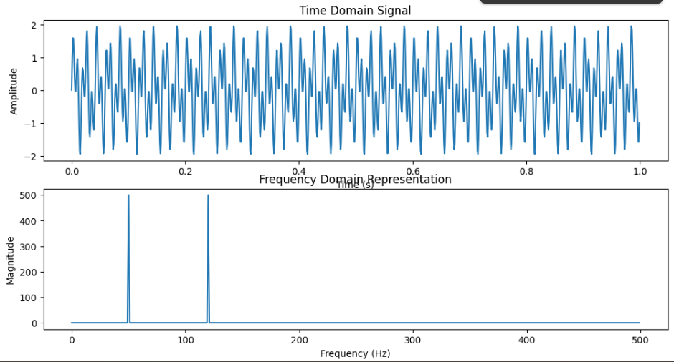

No of Experiment: 07
Name of Experiment: Fourier Series Decomposition with Harmonics
Objectives: To understand and implement the Fourier Series decomposition of periodic signals using Python. The Fourier Series represents a periodic function as a sum of sinusoidal harmonics, which helps in analyzing signal components.
Theory: The Fourier Series is a mathematical representation of a periodic signal as an infinite sum of sine and cosine functions. It is given by:
x(t)= a0+$\sum_{n=1}^{∞ }{1}$(an cos(nw0t) + bn sin (nw0t)
where:
- a0 is the DC component (average value of the function),
- an and are the Fourier coefficients,
- w0 is the fundamental angular frequency.
Applications of Fourier Series include:
- Signal decomposition in electrical and communication systems
- Harmonic analysis in power systems
- Audio signal processing

Python Code:
import numpy as np
import matplotlib.pyplot as plt
from scipy.signal import square

# Generate a periodic square wave signal
t = np.linspace(0, 1, 1000, endpoint=False)
f = 5 # Fundamental frequency
signal = square(2 * np.pi * f * t)

# Fourier Series Approximation
def fourier_series_approx(t, num_harmonics, f):
approx = np.zeros_like(t)
for n in range(1, num_harmonics * 2, 2): # Only odd harmonics
approx += (4 / (np.pi * n)) * np.sin(2 * np.pi * n * f * t)
return approx

harmonics = [1, 3, 5, 10] # Different levels of approximation
plt.figure(figsize=(12, 8))

for i, h in enumerate(harmonics, 1):
approx_signal = fourier_series_approx(t, h, f)
plt.subplot(2, 2, i)
plt.plot(t, signal, label='Original Signal', linestyle='dashed')
plt.plot(t, approx_signal, label=f'{h} Harmonics')
plt.xlabel("Time (s)")
plt.ylabel("Amplitude")
plt.legend()

plt.suptitle("Fourier Series Approximation of a Square Wave")
plt.tight_layout()
plt.show()

Output:
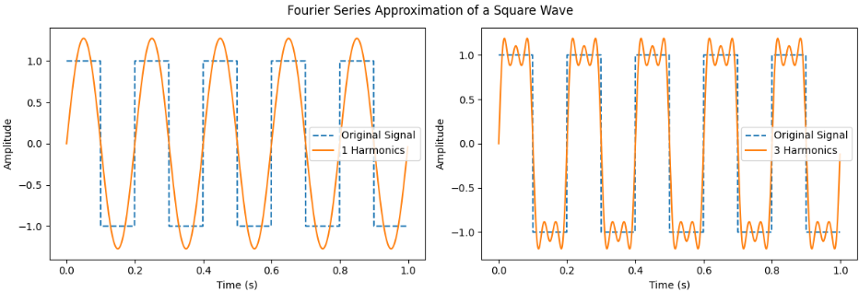
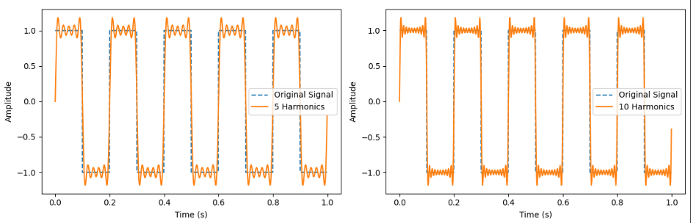

No of Experiment: 08
Name of Experiment: A lab report on DFT
Objectives: To analyze a Photoplethysmogram (PPG) signal using the Discrete Fourier Transform (DFT) to study its frequency components. This will help in understanding the spectral characteristics of the PPG signal, which is useful for applications such as heart rate monitoring and signal filtering.

Theory: A Photoplethysmogram (PPG) is an optical signal that measures blood volume changes in microvascular tissues. It is widely used in biomedical applications for heart rate and blood oxygen level estimation.
The Discrete Fourier Transform (DFT) is a mathematical technique used to transform a discrete-time signal from the time domain to the frequency domain. The DFT is defined as:
$X\left(k\right)=\sum_{n=0}^{N-1}{\left(x(n)e^(-j2πk/N\right)}$
where:
- X(k) represents the frequency components of the signal,
- x(n) is the time-domain signal,
- N is the total number of samples,
- k is the frequency index.
The Fast Fourier Transform (FFT) is an efficient algorithm for computing the DFT. It is widely used in digital signal processing to analyze frequency components of signals efficiently.

Python Code:
import numpy as np
import matplotlib.pyplot as plt
from scipy.fftpack import fft

# Simulated PPG signal (for real data, use sensor-acquired signals)
fs = 100 # Sampling frequency in Hz
t = np.linspace(0, 5, fs*5, endpoint=False) # 5 seconds duration
ppg_signal = np.sin(2*np.pi*1.2*t) + 0.5*np.sin(2*np.pi*2.4*t) + np.random.normal(0, 0.2, len(t))

# Compute FFT
N = len(ppg_signal)
fft_result = fft(ppg_signal)
frequencies = np.fft.fftfreq(N, 1/fs) # Frequency bins

# Plot PPG signal in time domain
plt.figure(figsize=(12, 5))
plt.subplot(1, 2, 1)
plt.plot(t, ppg_signal)
plt.title("PPG Signal in Time Domain")
plt.xlabel("Time (s)")
plt.ylabel("Amplitude")

# Plot magnitude spectrum
plt.subplot(1, 2, 2)
plt.plot(frequencies[:N//2], np.abs(fft_result[:N//2]))
plt.title("PPG Signal Spectrum (DFT)")
plt.xlabel("Frequency (Hz)")
plt.ylabel("Magnitude")
plt.grid()
plt.show()

Output:

